Website development retailer store
KHENSANI SITHOLE
ST10500261

Website Development Proposal
Prepared for: Sithole Family Retail
Date: March 30, 2026
Prepared by: [Your Name/Firm]

1. Executive Summary
Sithole Family Retail requires a modern, user-centric website to expand its customer reach, showcase products, and increase online sales. Currently, the business lacks a cohesive digital presence, relying on word-of-mouth and walk-in customers. This proposal outlines the development of a responsive, secure, and scalable e-commerce website designed to serve as the central hub for Sithole Family Retail’s operations, brand storytelling, and customer engagement.

2. Background & History
Sithole Family Retail was founded in 2010 in Pretoria by Mr. and Mrs. Sithole.
What began as a small spaza shop operating from their garage quickly grew into a beloved neighborhood retailer known for quality goods and personalized service. Recognizing the need for a reliable local supplier, the Sithole family expanded their offerings to include household essentials, fresh produce, and traditional African crafts. Over the last sixteen years, the business has grown to serve thousands of loyal customers in the greater Johannesburg area. The purpose of Sithole Family Retail is to provide quality products with the warmth and trust of a family-owned business.

3. Mission & Vision Statements
- Mission: To provide our community with quality products and exceptional service, rooted in the values of family, trust, and integrity.
- Vision: To be the most trusted family-owned retailer in South Africa, bridging the gap between convenience and community.

4. Target Audience
Audience | Needs
Local Customers | Easy access to products, store hours, location, promotions
Online Shoppers | Secure online ordering, delivery options, product variety
Wholesale/Bulk Buyers | Bulk pricing inquiries, corporate gifting, partnership opportunities

5. Website Goals & Objectives (KPIs)
Goal | Objective | KPI
Increase Online Sales | Enable e-commerce functionality | 30% of total revenue from online sales within 12 months
Expand Customer Reach | Attract customers beyond immediate locality | 20% increase in new customer acquisitions within 6 months
Showcase Product Range | Display inventory in an organized, searchable manner | 50% of users view at least 3 product pages per session
Build Brand Loyalty | Communicate family story and values | 15% increase in repeat customers within 6 months

6. Current Website Analysis
- No existing website – business relies solely on walk-in traffic and WhatsApp orders
- No online presence – limited discoverability on search engines
- Manual order management – orders are tracked via pen and paper or messaging apps
- No digital marketing – unable to capture customer emails or run targeted promotions

7. Proposed Features & Functionality
Feature | Purpose
Online Store | Product catalog with categories, search, and filter functionality
Shopping Cart & Checkout | Secure payment gateway (PayFast, Yoco) with delivery options
Inventory Management | Real-time stock tracking to prevent overselling
Customer Accounts | Order history, saved addresses, wishlist functionality
Specials & Promotions | Display weekly deals, loyalty rewards, and seasonal offers
WhatsApp Integration | Click-to-chat for customer support and order inquiries
Store Locator | Map showing physical store location with hours and contact details
Bulk Inquiry Form | For wholesale customers and corporate gifting requests

8. Design Approach
- Color Scheme: Warm Earth Tones (Terracotta, Deep Orange) and Cream – reflecting heritage, warmth, and African identity
- Layout: Mobile-first, responsive design optimized for smartphones
- Imagery: High-quality product photography with authentic images of the Sithole family and store

9. Low-Fidelity Wireframe
text
+-----------------------------------------------------------------------------------+
| [LOGO] Sithole Family Retail | Shop | About | Contact | [Cart] | [Search] |
+-----------------------------------------------------------------------------------+
| HERO SECTION |
| "Quality Goods, Family Values – Since 2010." |
| [Shop Now] [Weekly Specials →] |
+-----------------------------------------------------------------------------------+
| FEATURED CATEGORIES |
| [Household Essentials] [Fresh Produce] [Traditional Crafts] [Gifts] |
+-----------------------------------------------------------------------------------+
| WEEKLY SPECIALS |
| [Product 1 - 20% Off] [Product 2 - Buy 1 Get 1] [Product 3 - R50 Off] |
| [View All Specials →] |
+-----------------------------------------------------------------------------------+
| BESTSELLERS |
| [Product A] [Product B] [Product C] [Product D] |
+-----------------------------------------------------------------------------------+
| FAMILY STORY |
| "From a garage in Soweto to your neighborhood..." [Read Our Story →] |
+-----------------------------------------------------------------------------------+
| CUSTOMER TESTIMONIALS |
| "Best service in the area!" – Thabo M. | "Quality products!" – Lerato K. |
+-----------------------------------------------------------------------------------+
| NEWSLETTER |
| Get specials straight to your inbox. |
| [Email Input] --------------------- [Subscribe] |
+-----------------------------------------------------------------------------------+
| FOOTER |
| Store Hours | Location | Contact | WhatsApp | Delivery Info | Privacy Policy |
+-----------------------------------------------------------------------------------+
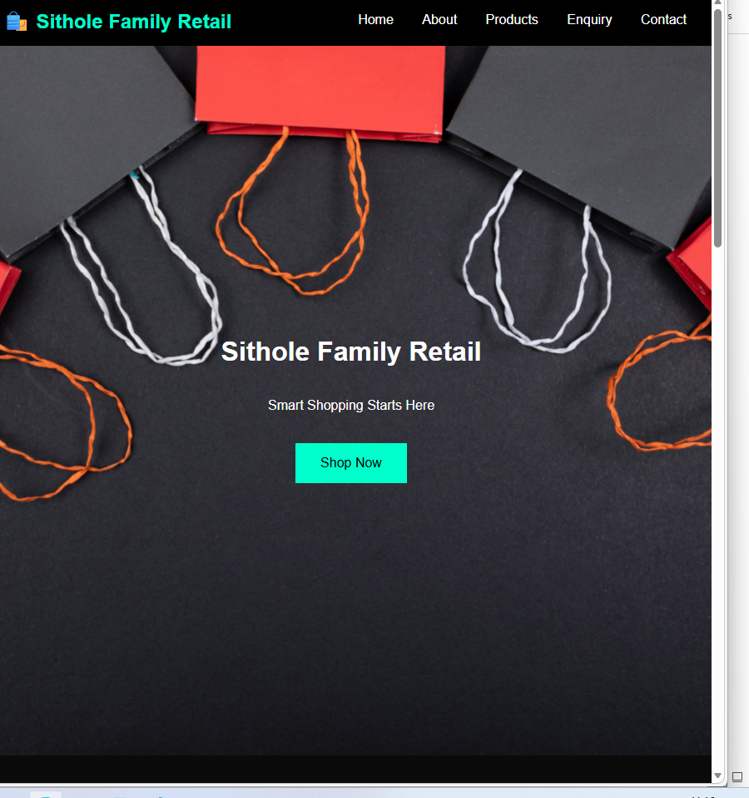

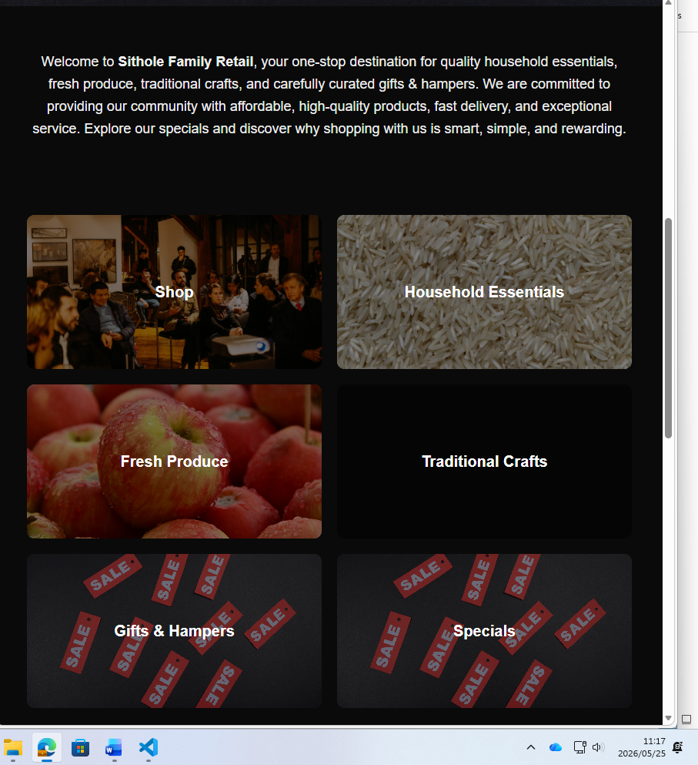

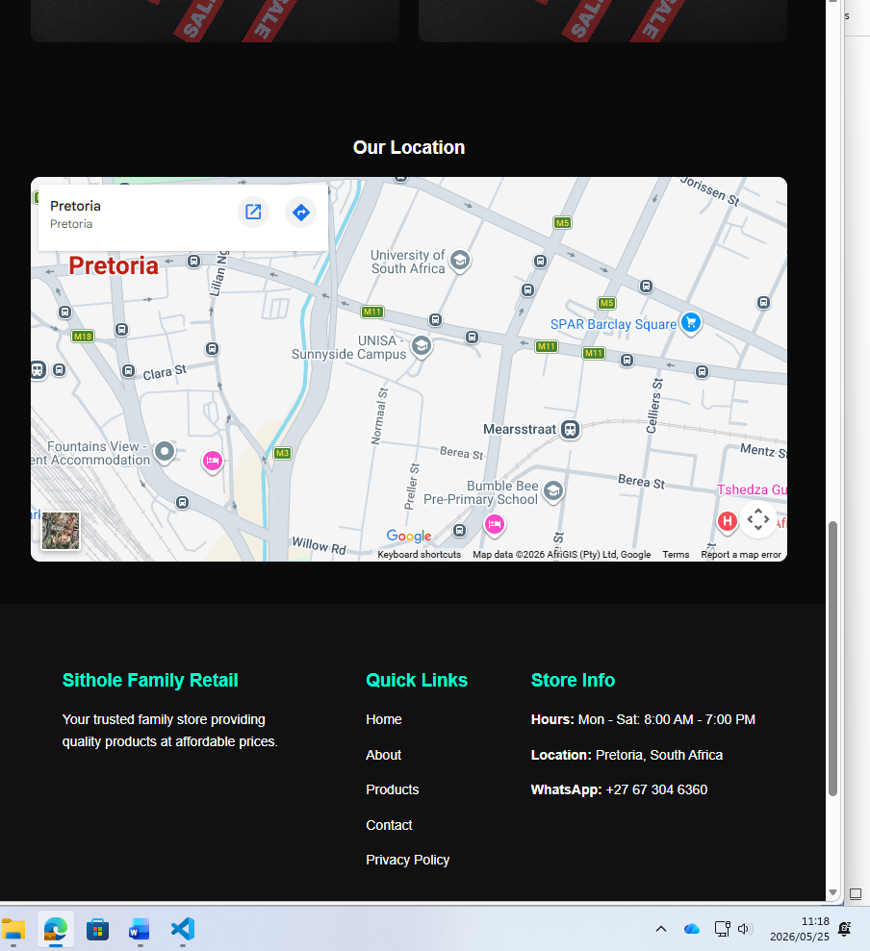

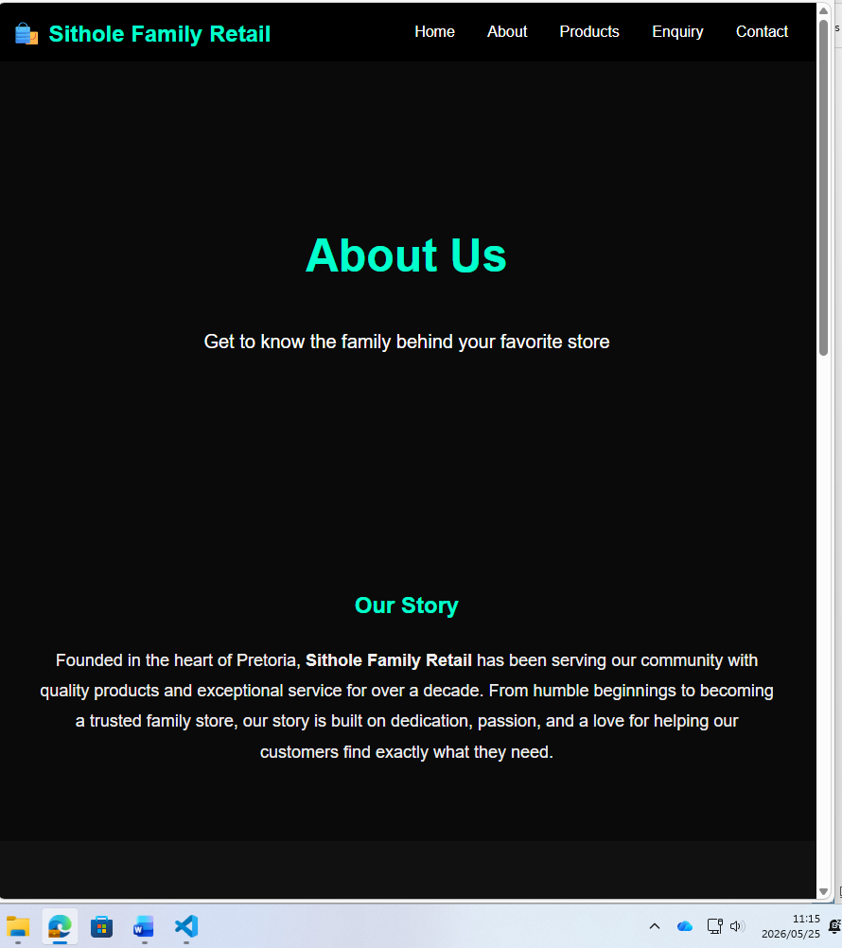

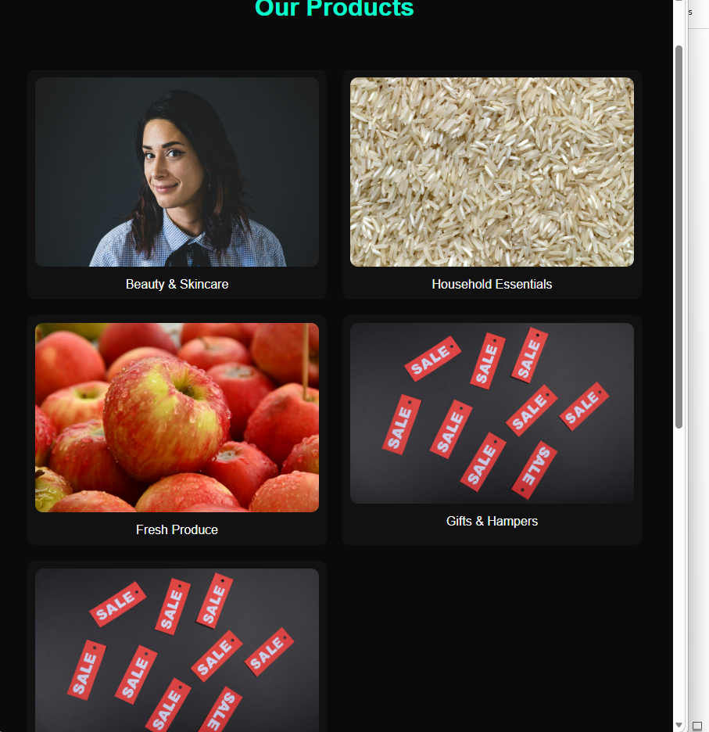

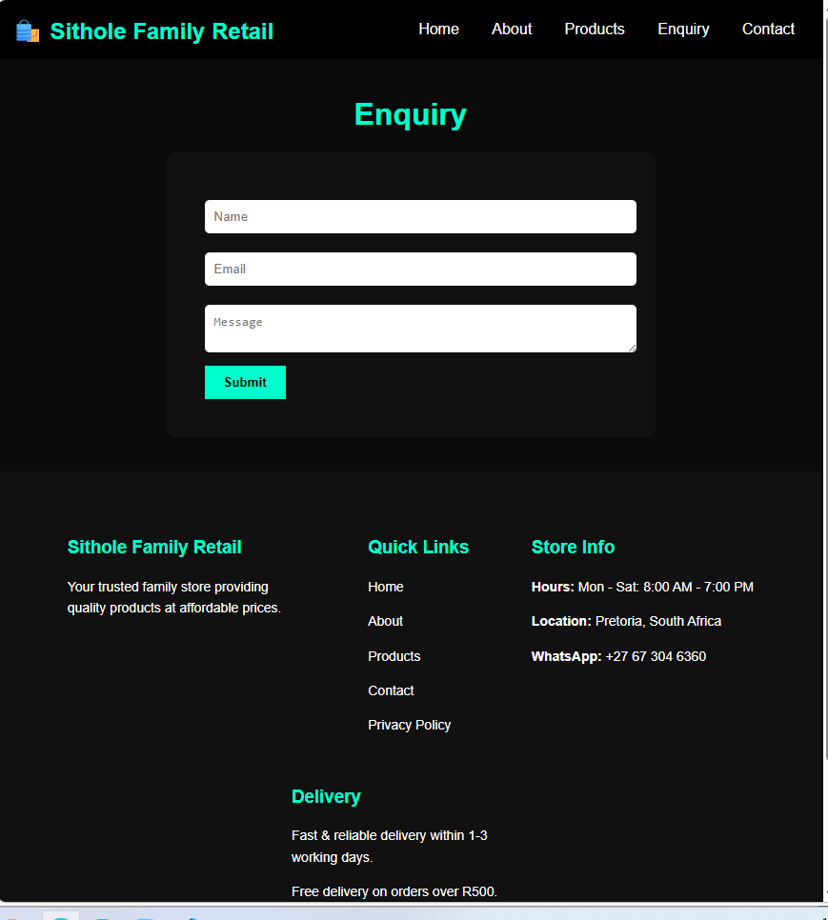

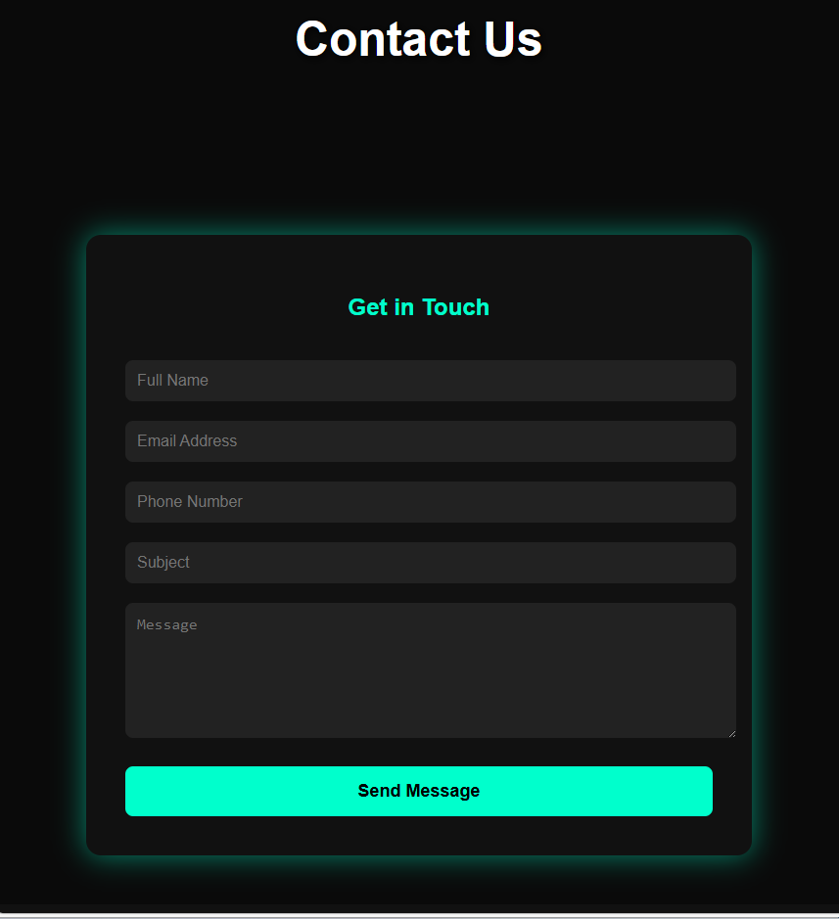

10. Sitemap
text
Homepage
│
├── Shop
│ ├── Household Essentials
│ ├── Fresh Produce
│ ├── Traditional Crafts
│ ├── Gifts & Hampers
│ └── Specials
│
├── About Us
│ ├── Our Story
│ ├── Mission & Values
│ └── Meet the Family
│
├── Customer Service
│ ├── Delivery Information
│ ├── Returns Policy
│ ├── FAQ
│ └── Contact Us

11. Technical Requirements
.HTML- structure of the website
.CSS- styling and layout
. JavaScript- interactivity

12. Timeline & Milestones
Phase | Activity | Duration
Phase 1 | Discovery & Product Catalog Setup | Week 1-2
Phase 2 | Design (Wireframes, Mockups) | Week 3-4
Phase 3 | Development (E-commerce setup, payment integration) | Week 5-8
Phase 4 | Testing & QA (Payment testing, mobile testing) | Week 9
Phase 5 | Training & Launch (Staff training on order management) | Week 10
Phase 6 | Post-Launch Support | Week 11-14
Total Timeline: 3.5 Months

13. Budget (South African Rand)
Item | Cost (ZAR)
Strategy & UX | R 46,250
UI Design | R 64,750
E-Commerce Development | R 185,000
Product Catalog Setup | R 27,750
Payment Gateway Integration | R 18,500
QA & Training | R 18,500
Hosting & Domain (Year 1) | R 11,100
Total One-Time Setup | R 371,850
Annual Maintenance (Retainer) | R 44,400/year
Note: Costs are estimates and may vary based on final scope. Payment gateway transaction fees are not included.

14. Conclusion
A website for Sithole Family Retail is an investment in the future of the business. By establishing a professional online presence, the business will be able to reach new customers, increase sales, and continue serving the community with the same family values that have made it successful for sixteen years.
We look forward to partnering with the Sithole family to bring this vision to life.

Approved by: ___________________________ Date: ___________

